FOUNDATION UNIVERSITY ISLAMABAD
SCHOOL OF SCIENCE AND TECHNOLOGY

ASSIGNMENT NO 03

NAME: ALISHBA HAFEEZ
SUBJECT: PF(programming fundametals)
SECTION: 25(B)
DEPARTMENT: BS IET
INSTRUCTOR: Mr. SHAMSHAIR
ROLL NO: 056
FORM NO: 1025234338

LAB MANUAL # 09

TASK 9.1:
Write a C++ program to enter and display student attendance records of 5 days using the array.
CODE:
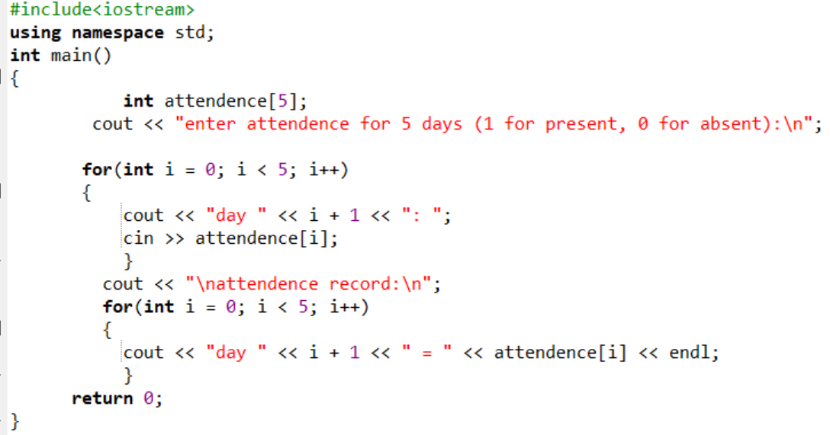

OUTPUT:
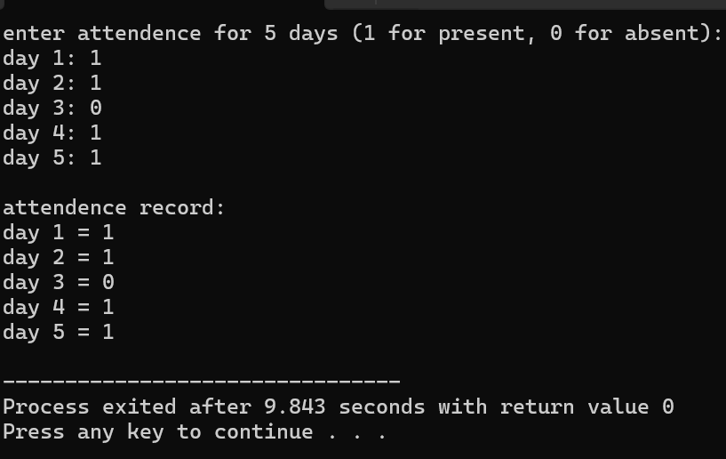

TASK 9.2:
Write a C++ program that declares two 3 x 3int arrays (Matrices). Store random values using
nested for loops in the array and perform Addition and Multiplication of Matrices, stores the
result of the operation in another Matrix (output arrays). And displays the results.
CODE:
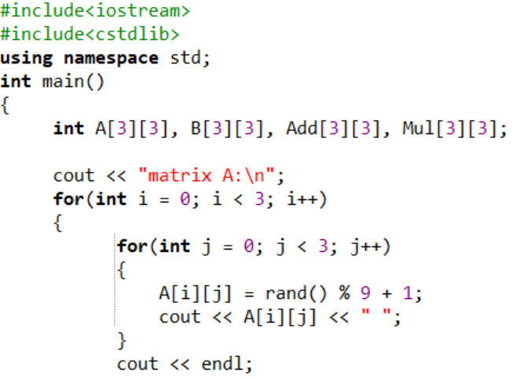
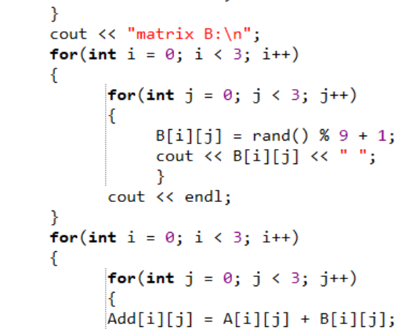
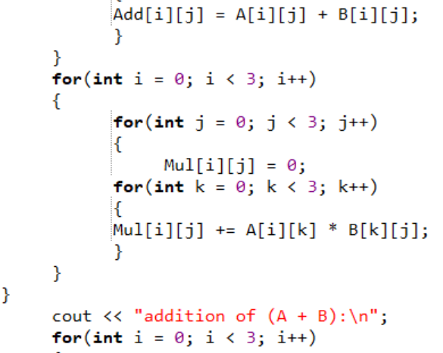
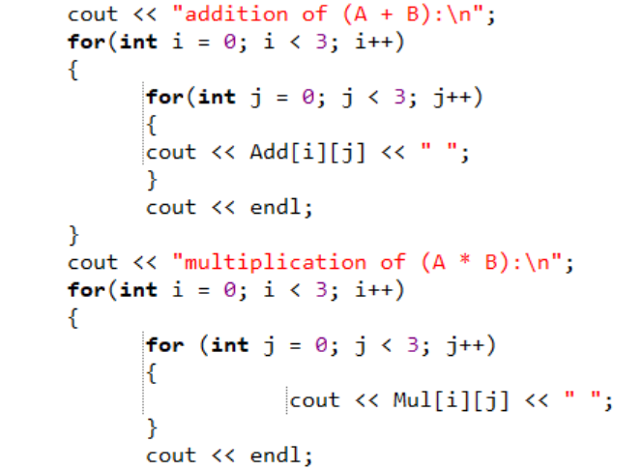
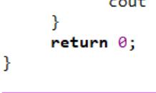
OUTPUT:
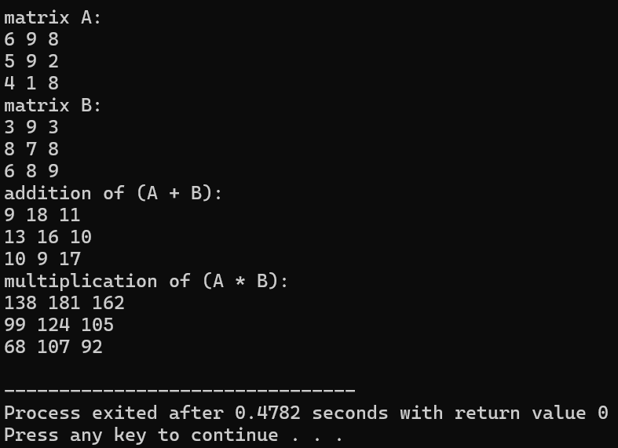

TASK 9.3:
Write a C++ program, which:
✔ Populates a two-dimensional array of size 10 x 10 with random numbers between 0
and 9 (Hint: C++ has a built-in function for random number generation)
✔ Prompts the user to enter a number.
✔ Searches for this number in the 10 x 10 array and
✔ Displays the location where the number is found in the array.
Your program should display ‘Value not found’ if the user’s specified number is not found in the
10 x 10 array. Your program should have the following interface.

CODE:
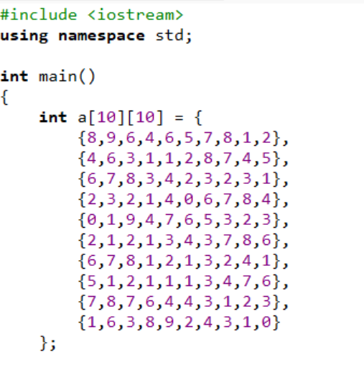
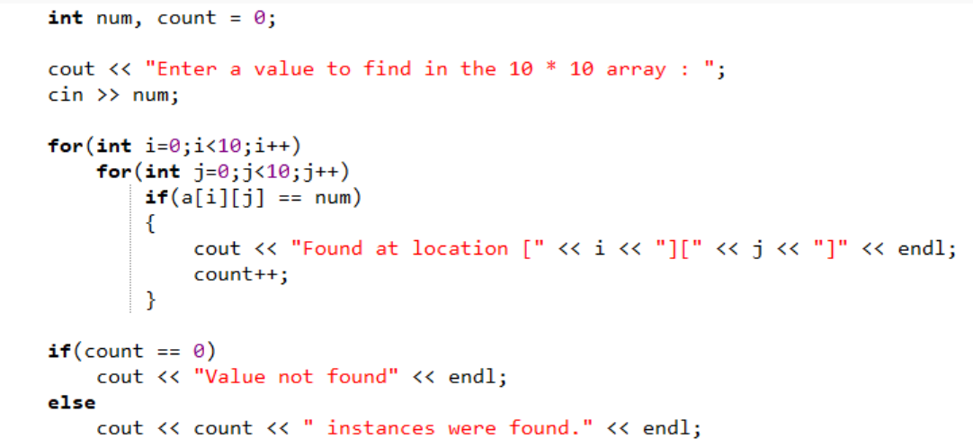
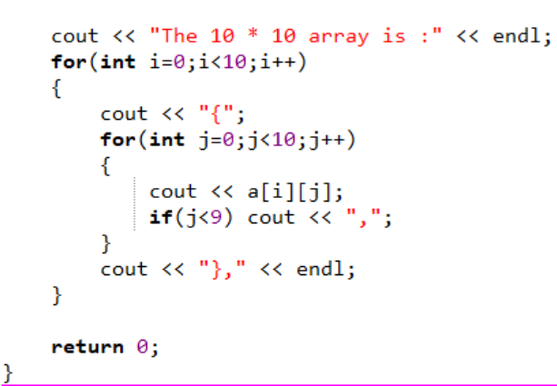
OUTPUT:
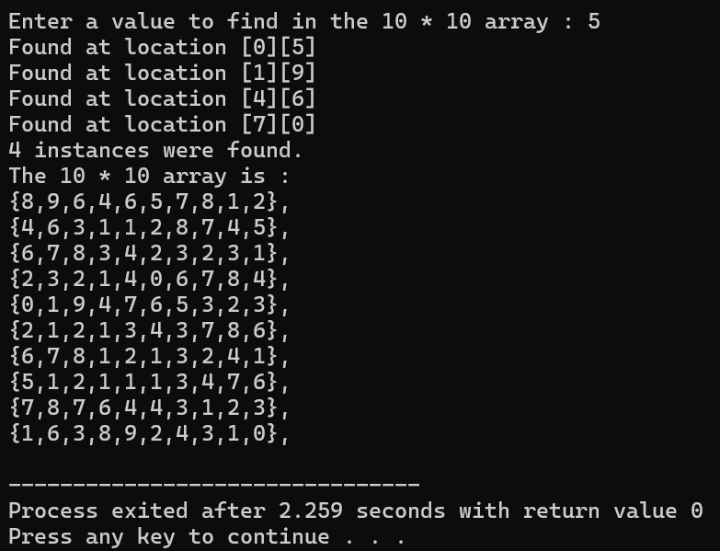

TASK 9.4:
Understand, Explain and show the output of the following code.
CODE :
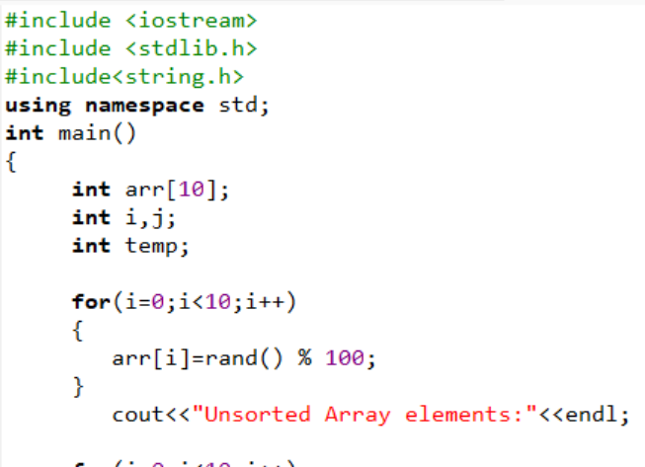
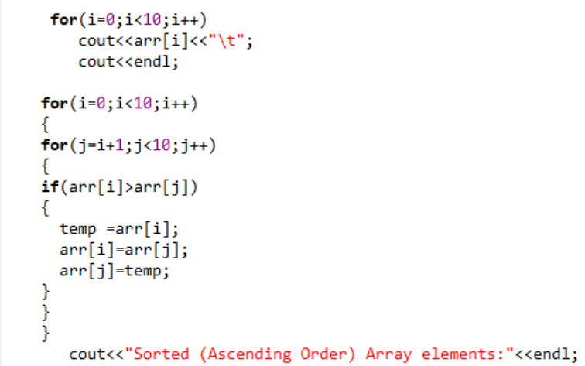
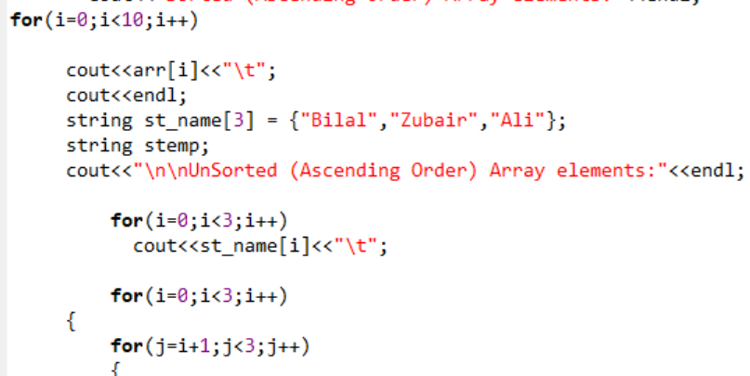
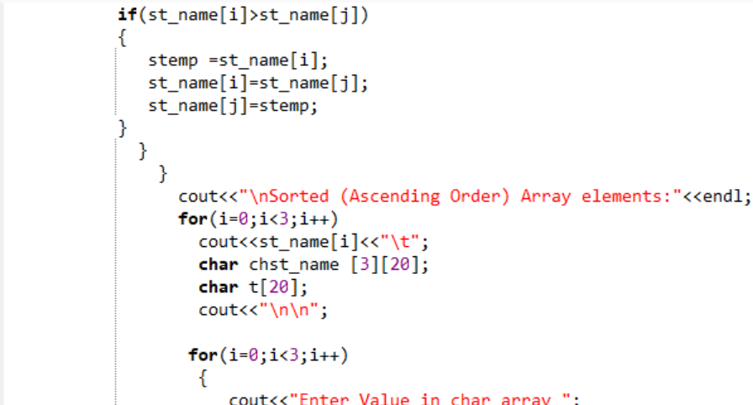
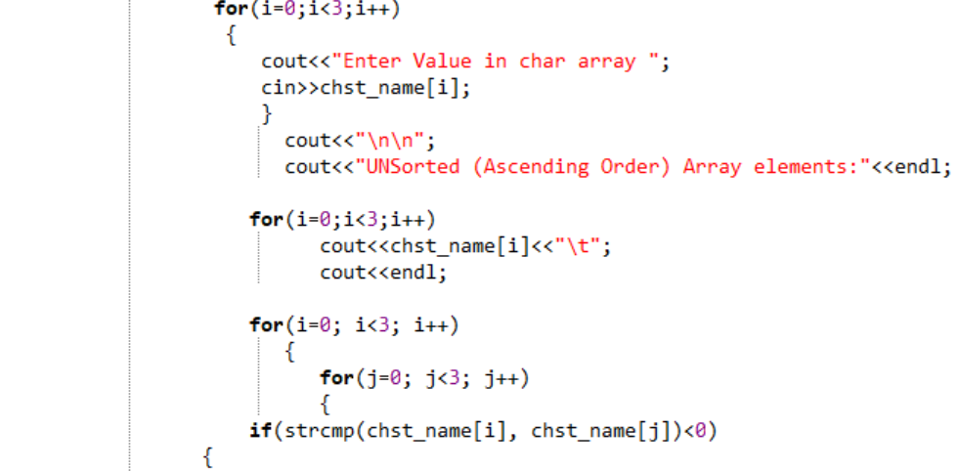
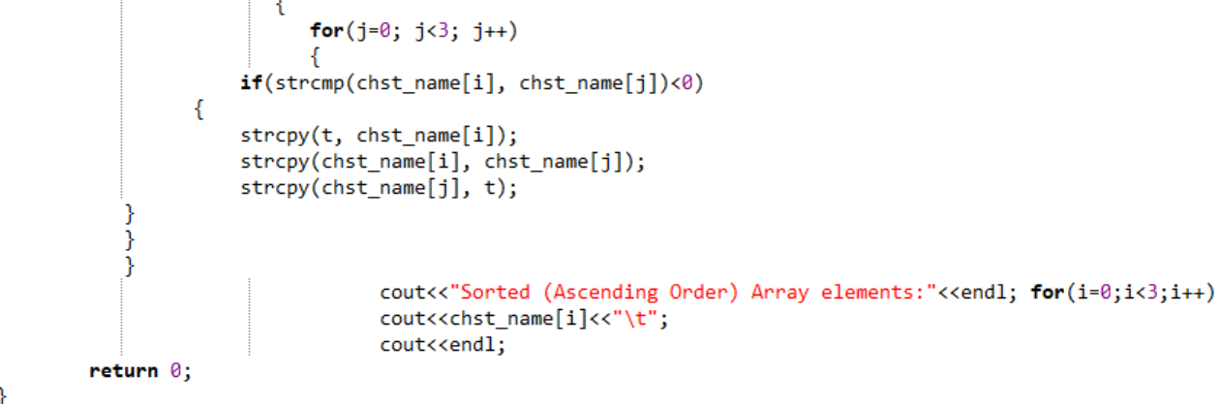
OUTPUT:
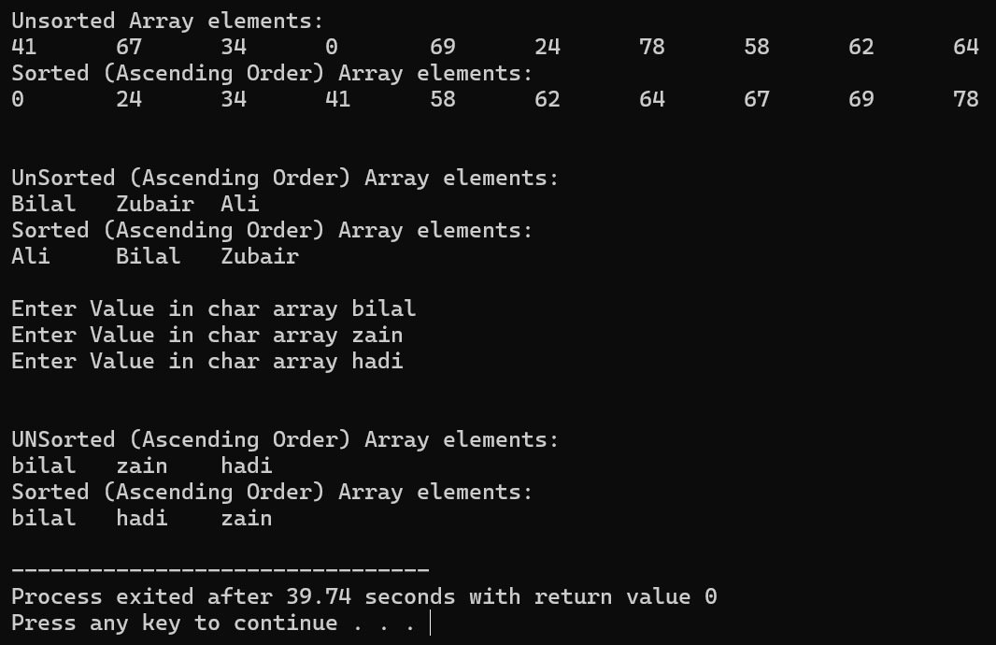

TASK 9.5:
Write down the output of the following code
CODE:
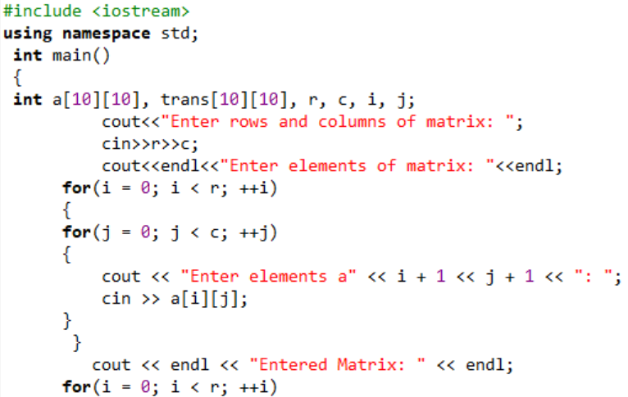
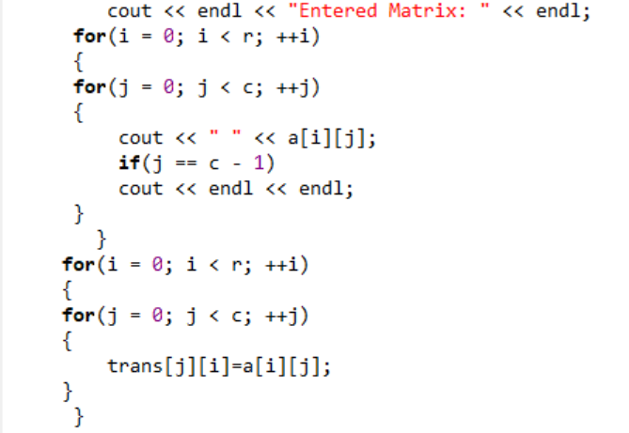
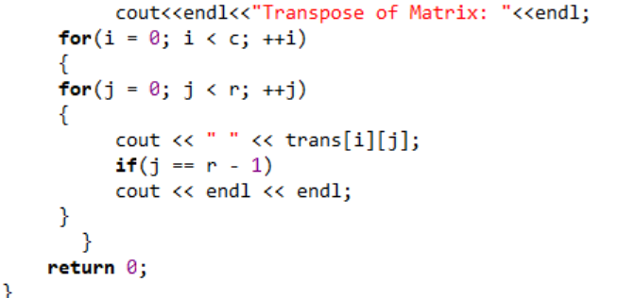

OUTPUT:
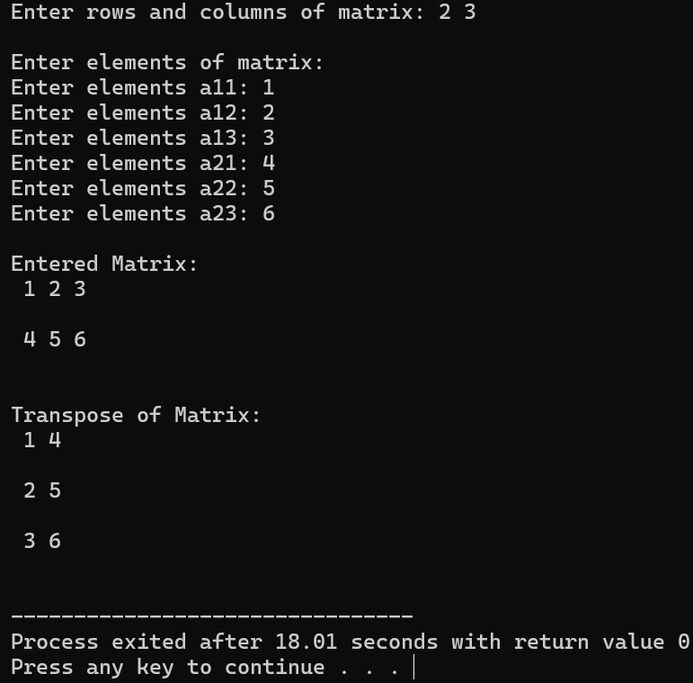
TASK 9.6:
Write down the output of the following code
CODE:
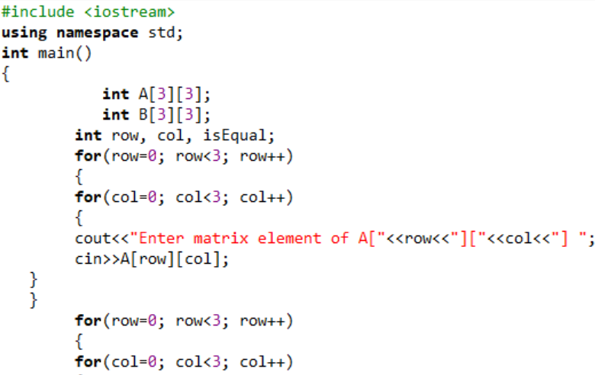
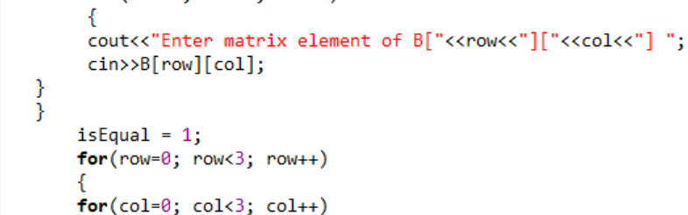
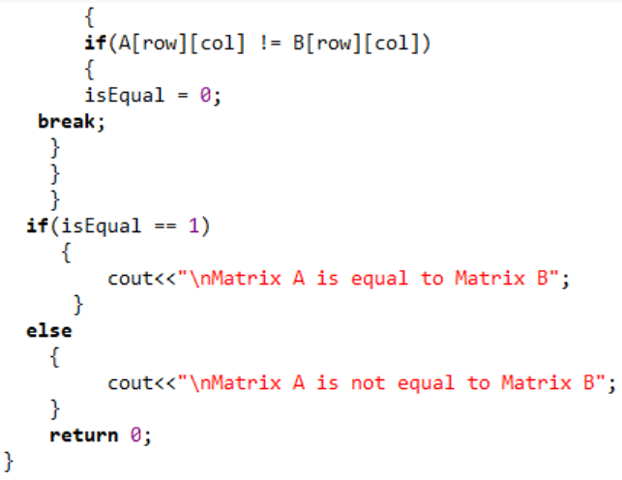

OUTPUT:
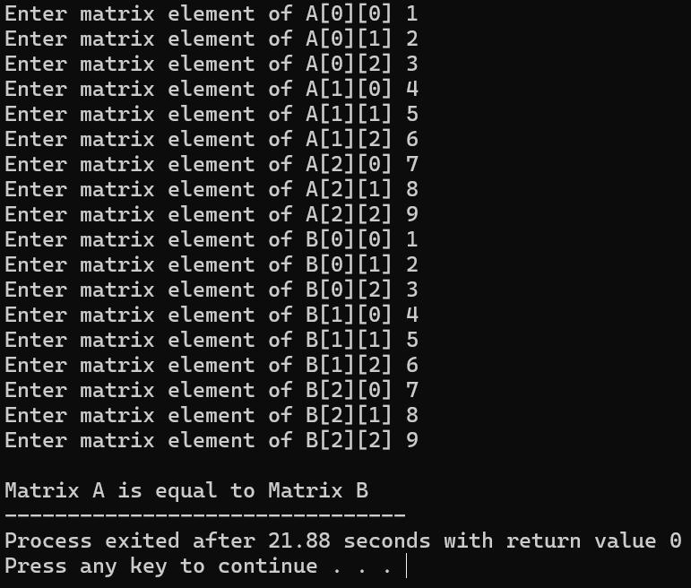

TASK 9.7:
Write down the output of the following code.
CODE:
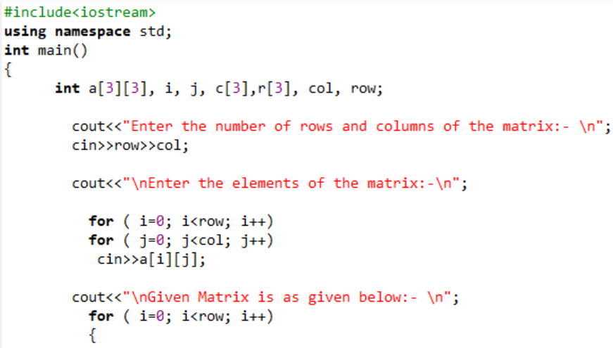
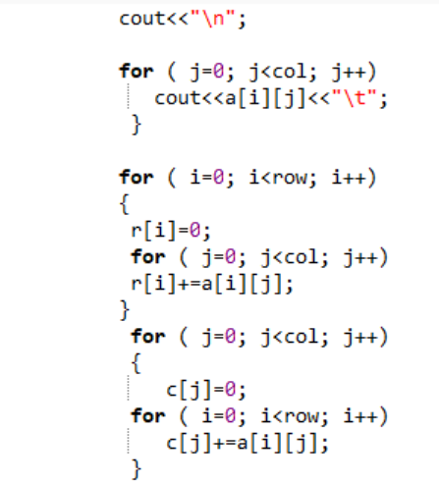
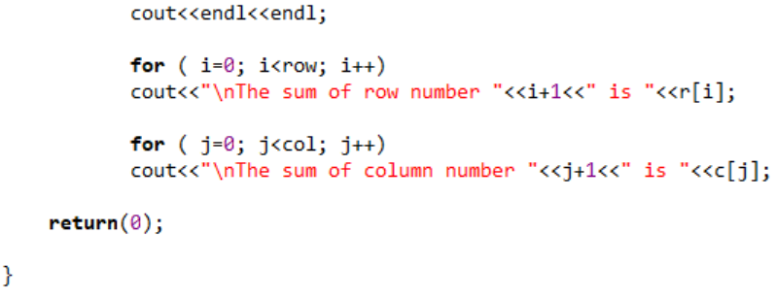

OUTPUT:
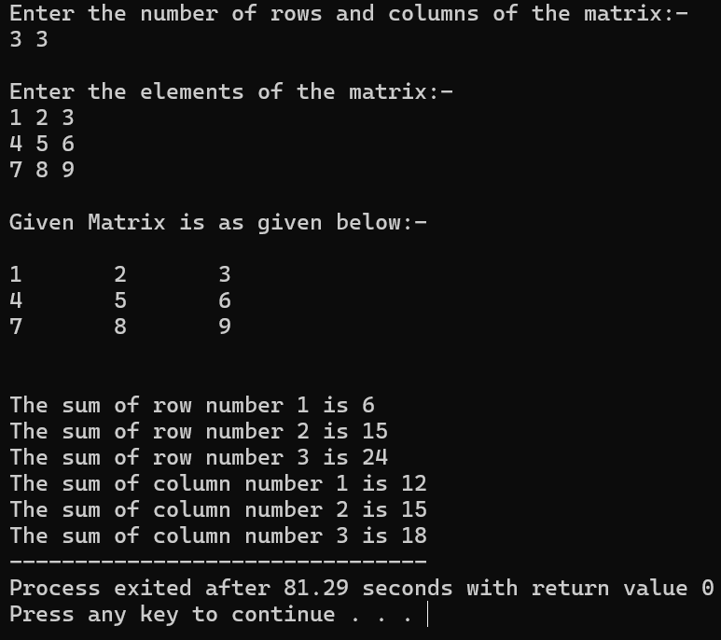
TASK 9.8:
Write down the output of the following code.
CODE:
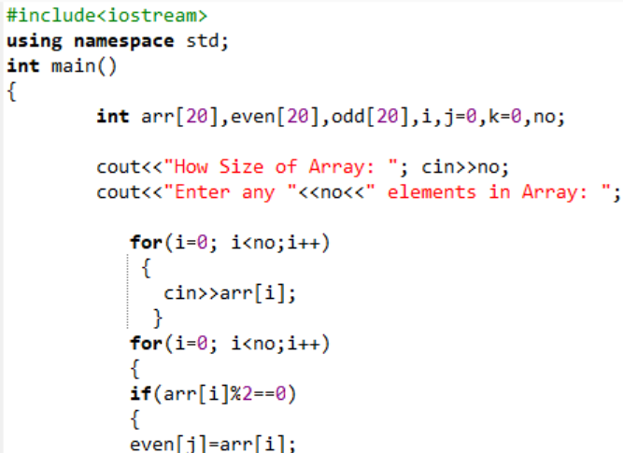
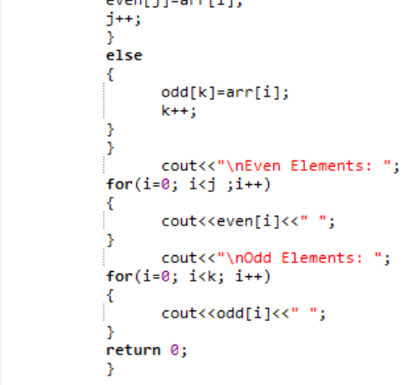

OUTPUT:
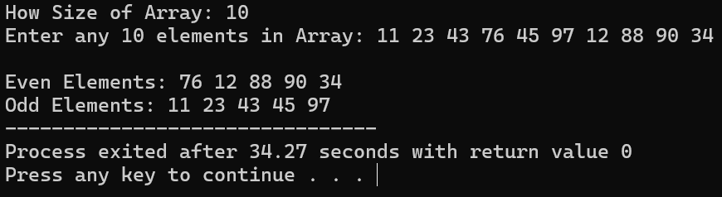

EXERCISE 9.1:
Write a C++ program, which:
✔ Declares and initializes an integer array of 20 indexes.
✔ Finds the minimum, maximum, sum and average of the elements of this array using
functions and,
✔ Prints these results on screen.
Your program should have the following interface.

CODE:
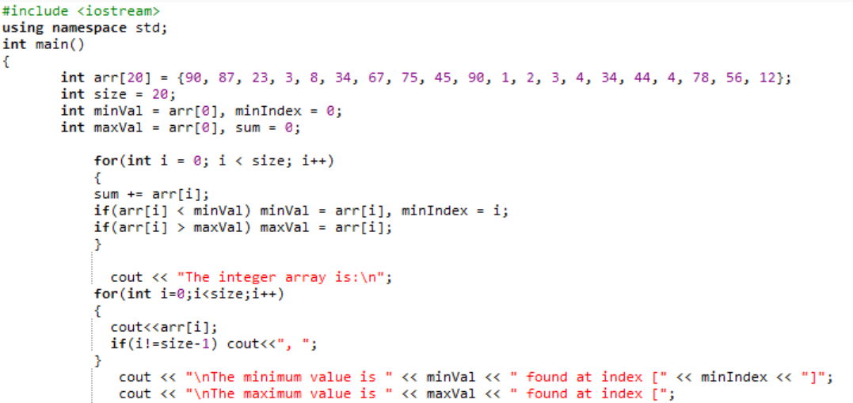
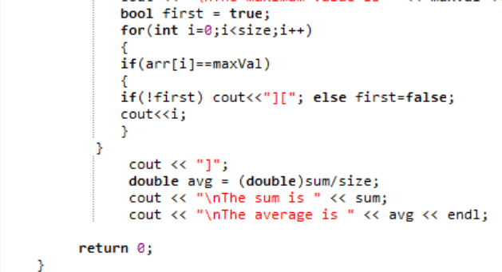

OUTPUT:
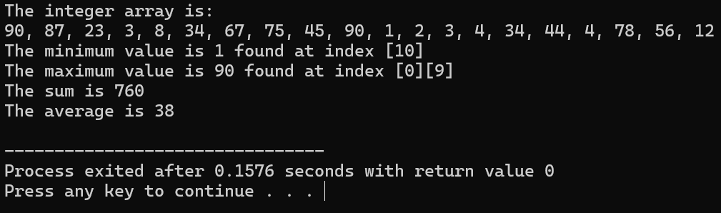
EXERCISE 9.2:
Take input from the user to show a 3 x 3 array. Then take input from the user and search for
that element in the array if element found in array, then show its index otherwise show the
message “Element not found”.
CODE:
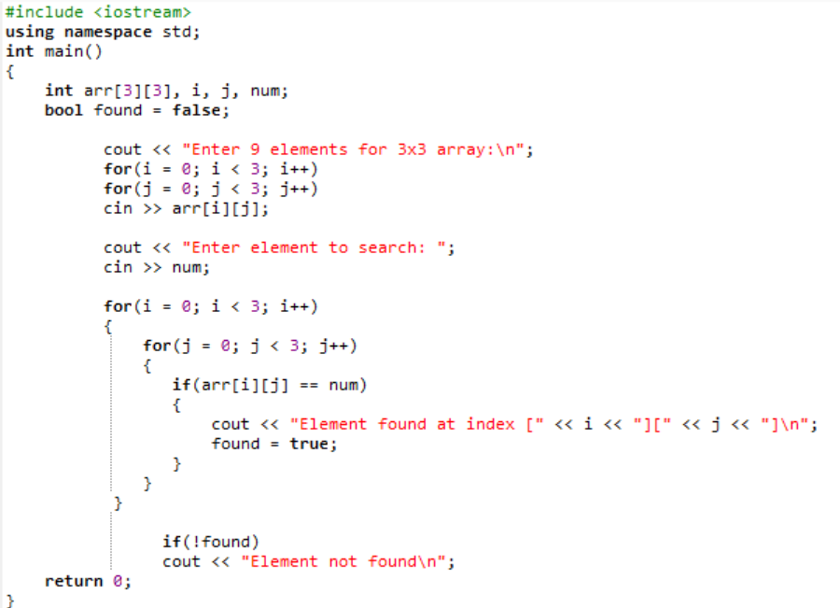

OUTPUT:
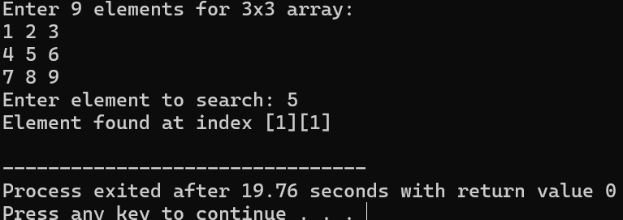

EXERCISE 9.3:
(Traversing through Two-Dimensional Arrays)
Write C++ program such that the program searches through the array to find maximum and
minimum values and displays them with their respective location numbers. Your program should
have the following interface. You can use the same array you declared in Task 9.3.

CODE:
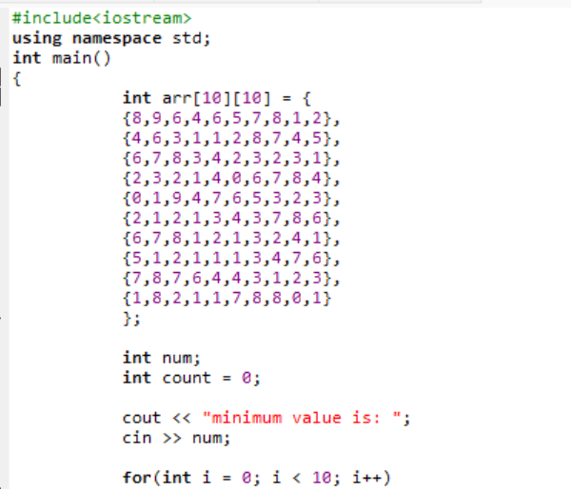
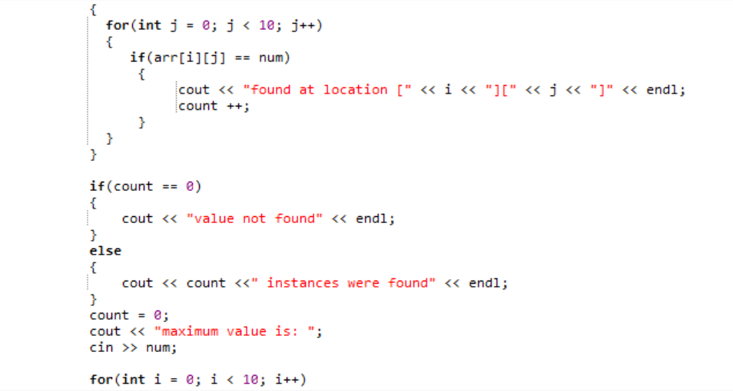
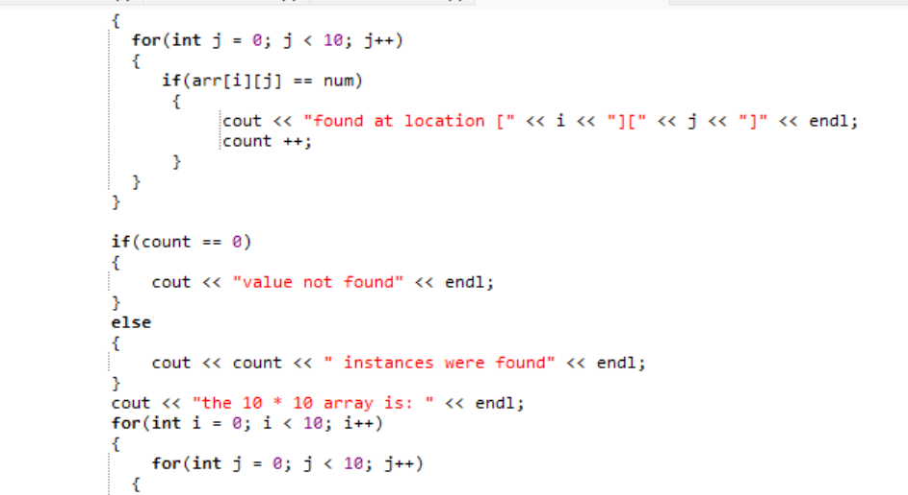
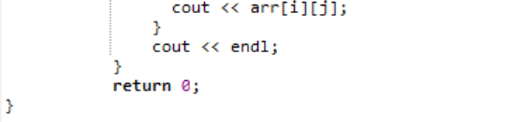

OUTPUT:
